|  |  |
| --- | --- |
| **Name:** | Rishav Dugar |
| **Roll Number:** | 19IM3FP30 |

1. **Aim of the experiment**

To study Zener Diode line regulation

1. **Tools used:**

Falstad

1. **Circuit (hand drawn/image)**

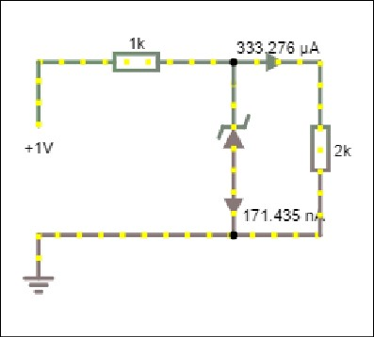

1. **Measurement Data (Tabular form)**

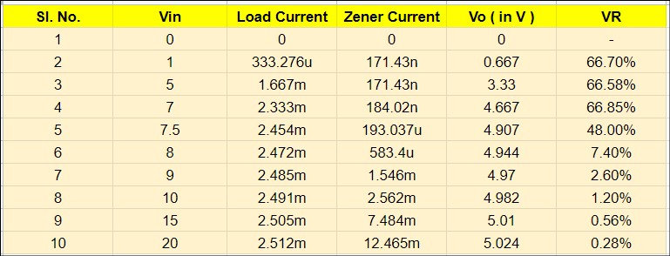

1. **Graph (Image)/Screenshots**

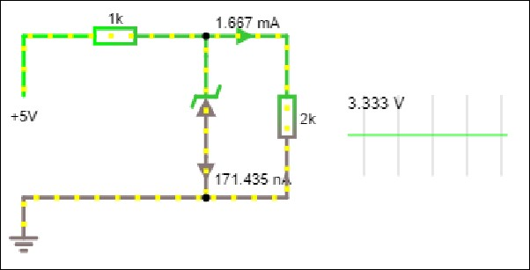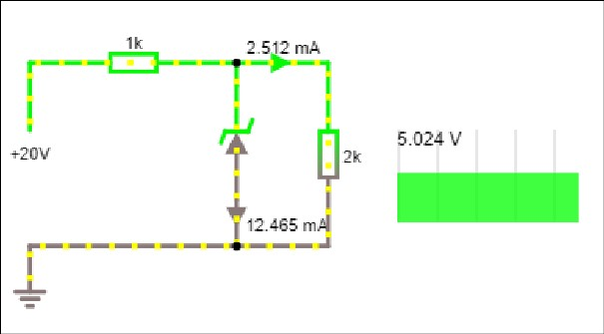

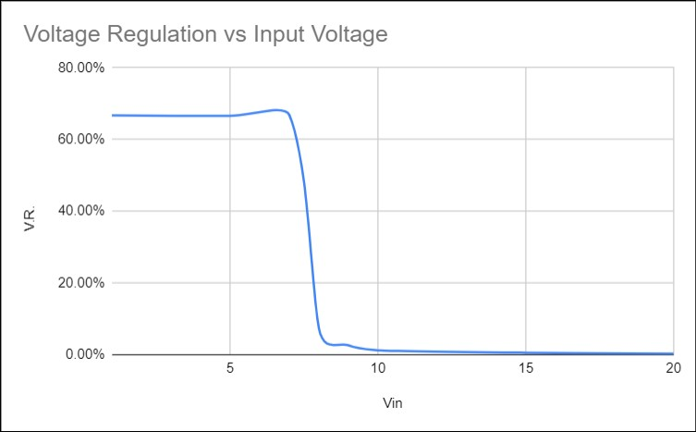

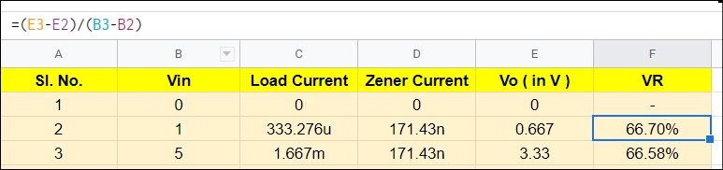

1. **Conclusion**

For Vi less than a minimum voltage the diode does not turn on. The minimum voltage can be calculated by Vz * (Rs+Rl) / Rl. In this case it is 7.5V.

For Vi greater than this value we get a near constant potential difference across the load.

Voltage Regulation = ( Change in Vo / Change ion Vi ) * 100 %

1. **Discussions**

Zener diode can be used in its breakdown region as a constant potential difference component. The line regulation helps us determine the stability of the circuit (output voltage ) with respect to changes in input voltage.